## Instructions for running the Melphalan Shiny App

Note: I built this application using R version 3.1.2 – the application should be fine with newer versions of R, but I can’t be sure with older versions.

1. Unzip the contents of the MelphPrototypeApp1.zip folder
2. Make sure you have the following R packages installed:

shiny 0.13.0

deSolve 1.12

plyr 1.8.3

ggplot2 2.0.0

grid 3.1.2

compiler 3.1.2

To run the Shiny application from RStudio (easiest way):

1. Make sure you have a recent version of RStudio – I am currently using RStudio version 0.98.977
2. Open the 3 R scripts in the unzipped MelphPrototypeApp1 folder – global.R, server.R and ui.R – in RStudio
3. RStudio should recognise that the group of scripts form a Shiny app. Click the “Run App” button which should appear on the top left viewer pane (as shown in RStudio screenshot below). RStudio will open up a new window to view the application. To run the application in RStudio (without opening a new window), click on the tab to the right of “Run App” and click “Run in Viewer Pane.” If you would like the application to run in your default web browser, i.e., Google Chrome, click “Run External.”

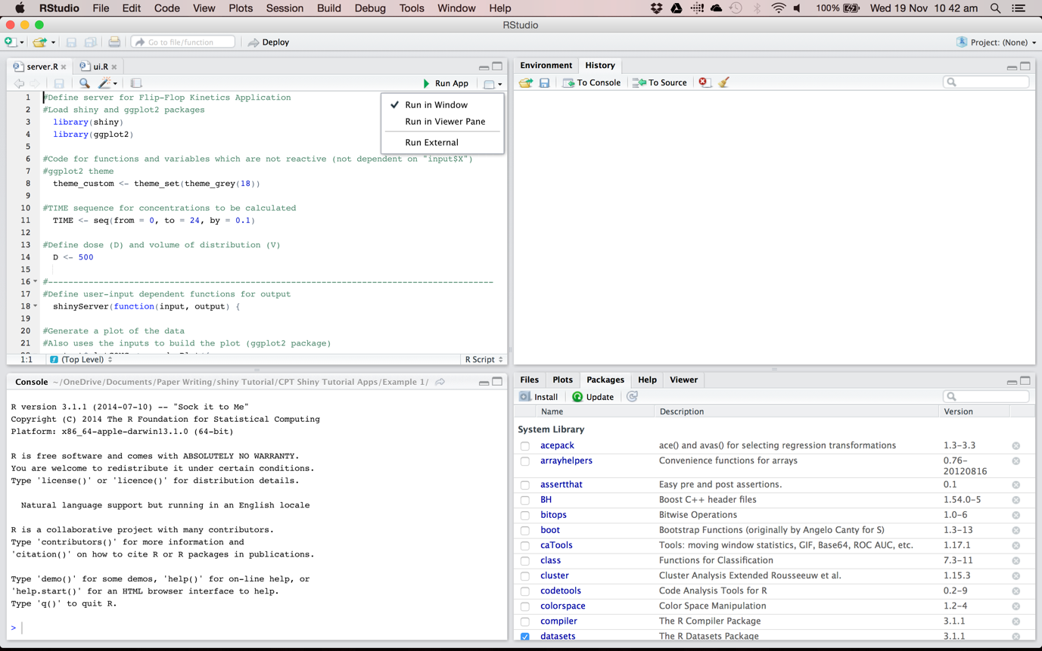

To run the Shiny application from R:

1. Load the above package libraries in R

library(shiny), etc.

1. Set the working directory that contains the unzipped MelphPrototypeApp1 folder using **setwd**

setwd(“C:/xxx/xxx/”)

1. Use **runApp** to run the Shiny application

runApp(“MelphPrototypeApp1”)